EE 255: ELECTRIC POWER

Experiment: Transformer Design

# (3 hours)

**DATE: …………………………………….. REG. NO: …………………………………. Selection of Core material:**

E/21/345

2025/06/04

The transformer core, which provides the flux linkage between the primary and secondary coils

of the transformer must be selected, based on:

1. Magnetization characteristics - the variation of flux density (B) with ampere-turn per meter (A)
2. Core loss - the variation of power loss per kg weight of the core (W) with flux density (B)

Manufacturers provide these characteristics as curves or tables. The core material selected for this particular case is grain oriented 3 silicon cold rolled steel (GOSS) laminate. For this laboratory class, consider the transformer core, which is constructed using laminates of the form and dimensions shown in Figure 1.

0.5 T

T

L

H= 1.5 T

#### 3 T S



Figure 1: Dimension of the transformer core

## Turns per volt ratio:

This depends on the core material and can be calculated as follows. For a sine wave supply, the induced e.m.f. (E) can be calculated by,

E = 4.44 . m . N . f (m= Maximum flux density) By substituting m= Bm . A , f= 50 Hz,

E = 4.44 . Bm . A . N . 50 . Sf

Here stacking factor Sf, which compensates the reduction in iron area because of the insulating layer on the lamination, can be taken as 0.9.

For the selected lamination materials, the maximum flux density can be taken as 1.0 Tesla.

#### A = T  S 10-6

E = 4.44 1.0 T S10-6 N 50 0.9

Turns per volt ratio = (N/E) = 5005 / (TS) Note: for an ideal transformer E = V.

The primary voltage of the transformer is 110 V and the induced voltage in the secondary has to be selected according to your group number. Using the (N/E) ratio calculated above, the number of turns required for primary and secondary can be calculated.

## Primary and secondary currents:

Iload,primary = VA / Vprimary and Iload,secondary = VA / Vsecondary For a small transformer, magnetizing current Im can be approximated to 30% of Iload,primary. Therefore, Im = Iload,primary  0.3

If the transformer is operated at full load at unity power factor operation, then the magnetizing

current is in quadrature with the load current.

Therefore, total current of primary coil at full load = (Iload2 + I 2)1/2

m

## Selection of coil wires for windings:

The winding coils are chosen so that they can withstand the maximum current (the current through the coil at maximum load) and are selected by referring to coil manufacturer’s data sheets e.g. See Appendix.

## Available window area:

Available window area = H  L –area loss when the bobbin is inserted (see Fig.2)

**=** H  L – 1.52L – 1.5(H-1.5-1.5) (mm2)



1.5 mm 1.5 mm

H

#### L T

Figure 2: Area loss due to bobbin

## Total area consumed by the coils:

Let d is the diameter of a copper a coil.

ratio of effective copper area = (d2/4)/(d2) = 0.78

|  |  |  |
| --- | --- | --- |
|  |  |  |
|  |  |  |
|  | d |  |

Figure 3: Total copper area

Total area consumed by the coils =

(Np cross sectional area of primary coil + Ns cross sectional area of secondary coil)/0.78

This should less than available window area.

## Pre-lab Calculations Data

Core size:

|  |  |  |
| --- | --- | --- |
| T | = | 25 mm |
| S | = | 26 mm |
| H | = | 38 mm |
| L  **Calculations** | = | 12 mm |

* 1. Calculate the number of turns required for the primary
  2. Calculate the number of turns required for the secondary
  3. Calculate Iload,primary, Iload,secondary, Im and total primary current
  4. Select suitable coils for primary and secondary windings using Table in Appendix. When you come to the lab, please check the availability of coils in the laboratory and select the nearest coil gauge for your calculated value.
  5. Calculate the total available window area and area consumed by the coils.

Check whether you can accommodate the windings within the window area available.

# Appendix

Table 01: Appendix

|  |  |  |  |
| --- | --- | --- | --- |
| Wire Gauge  (SWG) | Diameter/ mm | Area/ mm2 | Current/ A |
| 26 | 0.46 | 0.166 | 0.38 |
| 28 | 0.38 | 0.101 | 0.26 |
| 29 | 0.35 | 0.096 | 0.22 |
| 30 | 0.305 | 0.073 | 0.18 |
| 36 | 0.178 | 0.024 | 0.068 |
| 39 | 0.127 | 0.012 | 0.032 |
| 40 | 0.12 | 0.011 | 0.027 |

30, 36, 39, 40 - Primary Coil

26, 28, 29 - Secondary Coil

# EE 255 ELECTRIC POWER TRANSFORMER DESIGN

The rating of the transformers to be designed by the respective groups are given below. You should design your transformer according to those ratings. All the calculations should be done prior to the practical and you have to bring the report when you are attending to the practical.

Table 02

|  |  |  |  |
| --- | --- | --- | --- |
| Group No | VA rating | Primary Voltage/ V | Secondary Voltage/  V |
| 01 | 2 | 110 | 10 |
| 02 | 3 | 110 | 15 |
| 03 | 2 | 110 | 10 |
| 04 | 3 | 110 | 15 |
| 05 | 2 | 110 | 10 |
| 06 | 3 | 110 | 15 |
| 07 | 2 | 110 | 10 |
| 08 | 3 | 110 | 15 |
| 09 | 2 | 110 | 10 |
| 10 | 6 | 110 | 24 |
| 11 | 2 | 110 | 8 |
| 12 | 9 | 110 | 25 |
| 13 | 2 | 110 | 8 |
| 14 | 6 | 110 | 24 |
| 15 | 3 | 120 | 12 |
| 16 | 9 | 120 | 25 |
| 17 | 3 | 120 | 12 |
| 18 | 9 | 120 | 25 |
| 19 | 3 | 120 | 9 |
| 20 | 7 | 120 | 20 |
| 21 | 3 | 120 | 9 |
| 22 | 9 | 120 | 24 |
| 23 | 7 | 120 | 20 |
| 24 | 9 | 120 | 24 |
| 25 | 7 | 120 | 24 |
| 26 | 6 | 120 | 24 |
| 27 | 9 | 120 | 24 |
| 28 | 6 | 120 | 24 |

**Load Test**

### Apparatus

1. Single phase transformer
2. Variac (230V, 50 Hz)
3. Wattmeters – 2 Nos (120V/1A)
4. Voltmeters – 2 Nos (0-150V & 0-30V)
5. Ammeters – 2 Nos (0-0.5A)
6. Rheostat

### Procedure

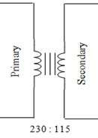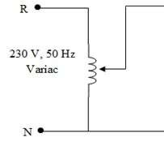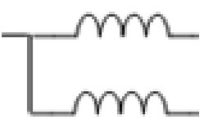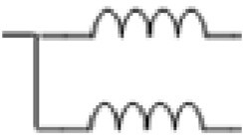

Wattmeter

120V/1A

0-0. A

Wattmeter

120V/1A

0-0.5

A A

V

V

Load

0-150V

0-30V

**v**

5

A

Figure 4: Load test circuit diagram

1. Connect the circuit as shown in figure 4 and set the variac to zero position.
2. Set the rheostat to the maximum position.
3. Adjust the variac and set the primary voltage to 230V.
4. Set the secondary current values as given in the table by varying the rheostat.
5. Record the readings of Wattmeters, ammeters and voltmeters.

### Observations Table 03: Observation data

|  |  |  |  |  |  |  |
| --- | --- | --- | --- | --- | --- | --- |
| Percentage full load(%) | Secondary current value (A) | Primary Side | | | Secondary Side | |
| Voltmeter/V | Ammeter/A | Wattmeter/W | Voltmeter/V | Wattmeter/W |
| 30 | 0.520 | 120 | 0.120 | 15 | 16.6 | 8 |
| 40 | 0.390 | 120 | 0.100 | 13 | 17.2 | 7 |
| 50 | 0.325 | 120 | 0.095 | 11 | 17.4 | 6 |
| 60 | 0.275 | 120 | 0.080 | 10 | 17.6 | 5 |
| 80 | 0.215 | 120 | 0.070 | 9 | 18.2 | 4 |
| 90 | 0.190 | 120 | 0.065 | 9 | 18.0 | 4 |
| 100 | 0.180 | 120 | 0.065 | 8 | 18.2 | 3 |

1

### Calculations

Considering the 7th data set of the table, PP=VP.IP.Cos(θ),

Power Factor, Cos(θ) = PP / (VP.IP)

= 8 / (120.0 × 0.65)

= 1.03

Voltage regulation = (VNL – VFL) × 100

VFL

= ((20- 18.2)×100) / 18.2

= 9.89%

Efficiency = POUT × 100

PIN

= 3 × 100 / 8

= 37.5%

### Results Table 04: Results

|  |  |  |  |
| --- | --- | --- | --- |
| Percentage full load (%) | Power Factor | Voltage Regulation (%) | Efficiency (%) |
| 30 | 1.04 | 20.48 | 53.33 |
| 40 | 1.08 | 16.28 | 53.85 |
| 50 | 0.96 | 14.94 | 54.55 |
| 60 | 1.04 | 13.64 | 50.00 |
| 80 | 1.07 | 9.89 | 44.44 |
| 90 | 1.15 | 11.11 | 44.44 |
| 100 | 1.03 | 9.89 | 37.50 |

* Plot the variation of Voltage regulation Vs. percentage full load and Efficiency Vs. Full load

**Tabulation & Graphs**

Table 05: Variation of Voltage Regulation vs Percentage Full Load

|  |  |
| --- | --- |
| Percentage full load (%) | Voltage Regulation (%) |
| 30 | 20.48 |
| 40 | 16.28 |
| 50 | 14.94 |
| 60 | 13.64 |
| 80 | 9.89 |
| 90 | 11.11 |
| 100 | 9.89 |

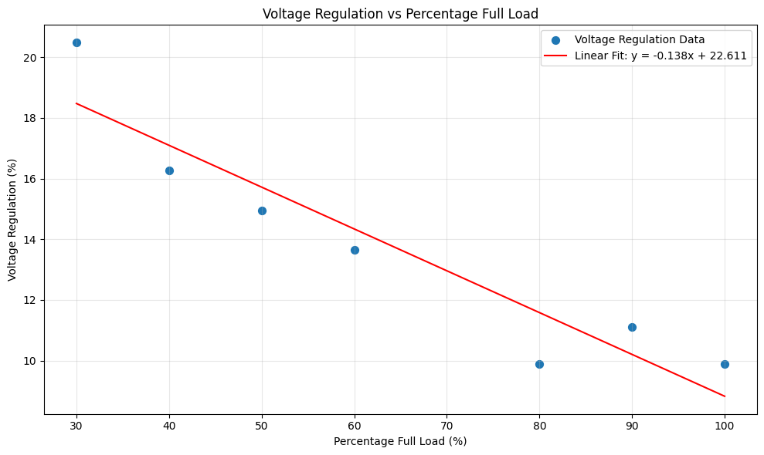

Figure 5: Voltage Regulation VS Percentage Full Load

Table 06: Variation of Efficiency vs Percentage Full Load

|  |  |
| --- | --- |
| Percentage full load (%) | Efficiency (%) |
| 30 | 53.33 |
| 40 | 53.85 |
| 50 | 54.55 |
| 60 | 50.00 |
| 80 | 44.44 |
| 90 | 44.44 |
| 100 | 37.50 |

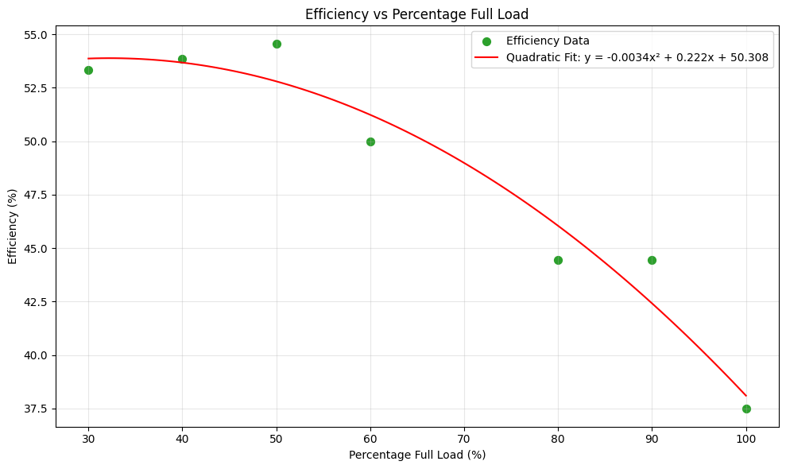

Figure 6: Efficiency VS Percentage Full Load

### Discussion

* 1. Compare and contrast the Voltage regulation Vs. percentage full load, obtained for the transformer used in the single phase transformer laboratory and that of the transformer wound by you. Clearly state the possible reasons for any deviation.

Table 07: Variation of Voltage Regulation vs Percentage Full Load transformer used in the single phase transformer laboratory and that of the transformer wound

|  |  |  |
| --- | --- | --- |
| Percentage full load (%) | Voltage Regulation for transformer wounded in lab (%) | Voltage regulation for transformer used single phase lab (%) |
| 30 | 20.48 | 2.68 |
| 40 | 16.28 | 2.68 |
| 50 | 14.94 | 0.877 |
| 60 | 13.64 | 2.68 |
| 80 | 9.89 | 4.55 |

As we can see from the above comparison table, the transformer wound in the lab shows significantly higher voltage regulation values across all load percentages compared to the standard transformer used in the single-phase laboratory. For instance, at 30% load, the wound transformer has a voltage regulation of 20.48%, whereas the lab transformer shows only 2.68%. Even at higher loads such as 80%, the wound transformer still shows 9.89%, while the lab transformer maintains a lower 4.55%.

This large deviation is likely due to several factors:

* Core material and construction quality: The lab transformer likely uses higher-grade materials with better magnetic properties and minimal core losses. In contrast, the wound transformer may have gaps or misalignments in the core laminations, increasing leakage reactance and resistance.
* Winding compactness and precision: The factory-made transformer likely has machine-wound coils with tight coupling, reducing impedance and maintaining voltage better under load. The hand-wound transformer may have loose or uneven windings leading to increased resistance and flux leakage.
* Load test conditions and measurement accuracy: Slight differences in how loads are applied and measured (e.g., contact resistance, meter calibration) could also introduce discrepancies.

Overall, the higher regulation in the wound transformer indicates greater voltage drop under load, which is expected mainly because of construction quality of the transformer.

* 1. Compare and contrast the Efficiency Vs. percentage full load, obtained for the transformer used in the single phase transformer laboratory and that of the transformer wound by you. Clearly state the possible reasons for any deviation.

Table 08: Variation of Efficiency vs Percentage Full Load transformer used in the single phase transformer laboratory and that of the transformer wound

|  |  |  |
| --- | --- | --- |
| Percentage full load (%) | Efficiency for transformer wounded in lab (%) | Efficiency for transformer used single phase lab (%) |
| 30 | 53.33 | 97.67 |
| 40 | 53.85 | 94.74 |
| 50 | 54.55 | 97.14 |
| 60 | 50.00 | 95.65 |
| 80 | 44.44 | 95.59 |

The efficiency of the transformer used in the lab is significantly higher than the wound transformer across all load conditions. For example, at 30% load, the lab transformer reaches an efficiency of 97.67%, whereas the wound transformer only achieves 53.33%. Even at higher loads (50%–80%), the lab transformer maintains efficiency above 95%, while the wound transformer's efficiency declines from 54.55% to 44.44%.

The key reasons for this deviation can be listed as folow:

* Higher copper and core losses in the wound transformer: Due to less efficient winding techniques, smaller wire gauges, and potentially imperfect joints, both copper losses (I²R) and core losses are likely elevated in the wound transformer.
* Lower power output and poor load matching: The efficiency calculation is highly sensitive to the output power. In the wound transformer, mismatch in winding turns or poor magnetic coupling may lead to a lower real output power and thus lower efficiency.
* Measurement and construction tolerances: Laboratory transformers are manufactured with precision, whereas hand wound transformers we made might have inconsistencies in insulation, wire tension, or contact points, all affecting performance.

In summary, the wound transformer has much lower efficiency due to greater internal losses and construction limitations, while the lab transformer benefits from optimized design, precise construction, and high-quality materials.

**References**

[1] Oshadha345, “Electrical-Power/University Work/Transformer Design Lab/Trnaformer_Design_Lab_report.ipynb at main · Oshadha345/Electrical-Power,” GitHub, 2025. <https://github.com/Oshadha345/Electrical-Power/blob/main/University%20Work/Transformer%20Design%20Lab/Trnaformer_Design_Lab_report.ipynb>

(accessed Jul. 24, 2025).

[2] Electronics Tutorials, “Transformer Construction of the Core and Transformer Design,” *Basic Electronics Tutorials*, Jul. 31, 2018. <https://www.electronics-tutorials.ws/transformer/transformer-construction.html>

(accessed Jul. 24, 2025)

‌

‌